FILDAS: A DIGITAL DOCUMENT ARCHIVING AND MANAGEMENT SYSTEM FOR THE QUALITY ASSURANCE OFFICE OF FILAMER CHRISTIAN UNIVERSITY, INC.

A CAPSTONE PROJECT
Presented to
The College of Computer Studies
Filamer Christian University
Roxas City

In Partial Fulfillment
of the Requirements for the Degree of
BACHELOR OF SCIENCE IN COMPUTER SCIENCE

By

LOR FREDERICK JAMES R. AQUINO
JOSEPH MARIE D. BANAY
REI ASHLEY DOLFO
STEFAN JOHN M. EBACUADO

October 1, 2025

TABLE OF CONTENTS

Title Page i
Table of Contents ii
List of Figures iii
List of Appendices iv
I Introduction
Overview 1
Desired 2
Statement 2
Objectives
General 3
Specific 4
Frameworks
Theoretical 5
Conceptual 6
Operation Definition 8
Scope 9
Significance 10
II Review of Related Literature 12
III Methodology 24
Bibliography 29

CHAPTER I
INTRODUCTION
Overview of the Current State of Technology
Document Management Systems (DMS) are essential tools designed to capture, store, manage, and track electronic documents throughout their lifecycle. They play a critical role in enhancing organizational efficiency, ensuring compliance with policies and regulations, and maintaining document security. Effective DMS solutions provide advanced functionalities such as automated workflows, version control, audit trails, role-based access controls, and integration with other enterprise systems. These features help reduce manual work, minimize errors, and support robust document governance tailored to an organization’s specific needs.
Despite these advantages, many organizations, including Quality Assurance (QA) offices within educational institutions, currently rely on generic cloud storage platforms like Google Drive as their primary method for document management. While such platforms offer basic file storage and sharing capabilities, they lack many of the specialized features that dedicated DMS solutions provide. This reliance often results in staff manually uploading, organizing, renaming, and verifying files, which is time-consuming and prone to human error. Furthermore, these platforms typically do not support automated notifications of new or updated documents, comprehensive versioning, detailed audit logs, or granular access permissions, which are vital for effective document control.
These limitations lead to operational inefficiencies, increased risk of document mismanagement, and difficulty in maintaining compliance with organizational standards and legal requirements. Consequently, standard cloud storage solutions are often inadequate to fully support the complex workflows and security requirements demanded by modern document management, prompting organizations to consider transitioning to purpose-built DMS platforms.

Desired State of Technology
The Desired State of Technology for Quality Assurance (QA) office is a purpose-built, automated, and secure Document Management System (DMS) specifically designed to address their unique operational requirements. This system should simplify document-related activities by automating the uploading, organizing, and verification of files, thereby significantly reducing manual effort and minimizing errors. Essential features include automated notifications that alert staff to new or updated documents from different departments, advanced file tracking capabilities, and robust role-based access controls to protect sensitive information. Additionally, a user-friendly interface that offers quick access to frequently used or pinned documents enhances overall productivity. Ultimately, such a system should improve efficiency, accuracy, collaboration, and data security, enabling QA offices to more effectively uphold quality standards and ensure compliance.

Statement of the Problem
The Quality Assurance (QA) office at Filamer Christian University struggles with an inefficient file management system that relies heavily on manual work. Staff spend excessive time uploading, organizing, and verifying documents tasks made even harder by limited personnel and no automated alerts for new or updated files. This lack of automation results in poor document tracking, delays, and increased errors, ultimately undermining the office’s ability to maintain accurate and timely records essential for quality assurance.
Specific Problems:
- The QA office relies on manual uploading, organizing, and verifying of documents, which causes inefficiencies and workflow bottlenecks that slow down operations.
- The absence of automated notifications for new or updated documents leads to delayed awareness and poor coordination between departments.
- Difficulty in sharing documents securely and efficiently among departments, including challenges in handling bulk downloads and uploads, results in miscommunication, duplicated efforts, and risks to document integrity.
- Difficulty in retrieving and searching for files causes wasted time and reduces staff productivity.
- The lack of comprehensive audit trails and activity logs undermines accountability and complicates error detection and compliance tracking.

Objectives of the Study
General Objectives:
To design and develop an automated, user-friendly, and secure FilDAS: a Digital Document Archiving and Management System for the quality assurance office of Filamer Christian University, Inc. that streamlines document handling, enhances real-time tracking and notifications, enforces role-based access controls, improves document retrieval and accountability, and supports effective user adoption, ultimately increasing efficiency, accuracy, and document security.

Specific Objectives:
- To create a Document Management Module that will automate document uploading, organizing, and verification features to reduce manual workload and eliminate workflow bottlenecks.
- To create a Notification Module that allows staff to keep to be informed of the submitted documents and improves coordination between departments.
- To create a Document Sharing and Access Control Module to establish secure and efficient document sharing functionalities with role-based access controls and to support bulk download and upload capabilities, facilitating collaboration while protecting sensitive information.
- To create a Document Retrieval and Search Module to efficiently find documents and improve search functionalities including categorization and metadata tagging, to minimize time spent locating files and enhance productivity.
- To create an Audit and Activity Logging Module that incorporates comprehensive audit trails and activity logs that record all document-related actions to promote accountability, facilitate error detection, and support compliance monitoring.

Theoretical and Conceptual Framework of the Study
Figure SEQ Figure \* ARABIC 1. Theoretical Framework of the Study
Theoretical Framework of the Study
Figure SEQ Figure \* ARABIC 1. Theoretical Framework of the Study
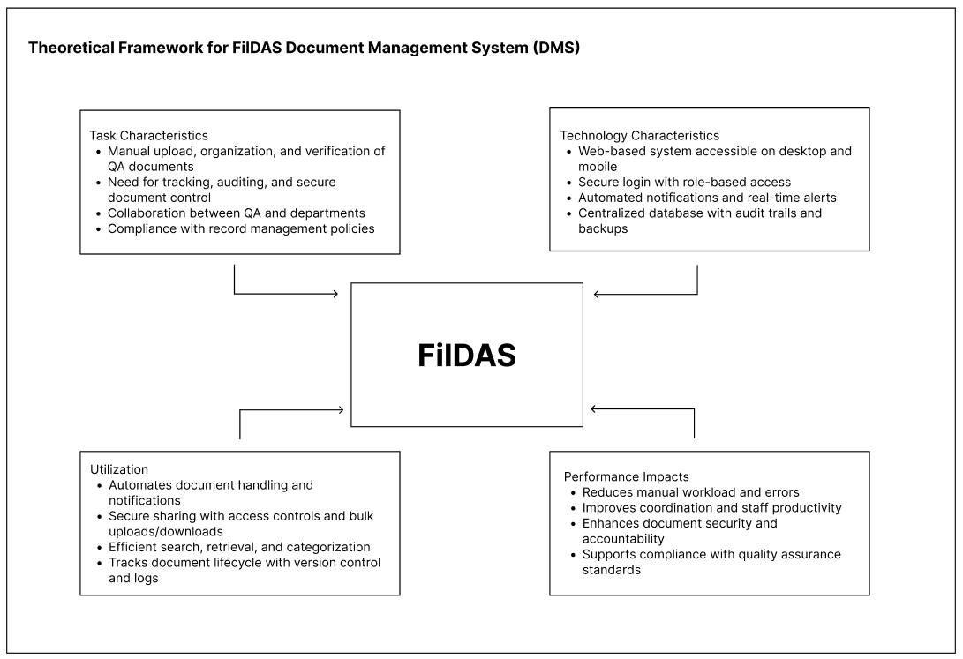
Figure 1. Theoretical Framework of the Study

This study is grounded in the Task-Technology Fit (TTF), developed by Goodhue and Thompson, which posits that the success and effective adoption of any technology depend largely on the degree to which the technology's capabilities match the specific tasks users need to perform. According to TTF, when there is a strong alignment between the features of a system and the requirements of the users’ tasks, this fit enhances user performance and satisfaction.
In the context of this study, the Document Management System (DMS) is designed to closely align with the document-related tasks of the Quality Assurance (QA) office, such as uploading, organizing, verifying, retrieving, sharing, and securing electronic documents. By tailoring system functionalities like automated notifications, role-based access control, and audit trails to the precise needs of these tasks, the DMS aims to reduce manual workloads, minimize errors, and facilitate smoother workflows.
This alignment not only supports more efficient task completion but also encourages user acceptance and sustained use of the system. Therefore, the TTF framework provides a valuable theoretical basis for evaluating how well the proposed DMS meets the operational needs of the QA office and contributes to enhanced work performance and quality assurance effectiveness.
The conceptual framework for the FilDAS Document Management System (DMS) serves as a structured visualization of how the system addresses the core document management challenges faced by the Quality Assurance (QA) Office at Filamer Christian University. It maps out the relationships between user roles, system modules, and the central database, underscoring the project’s alignment with principles of security, efficiency, and compliance.
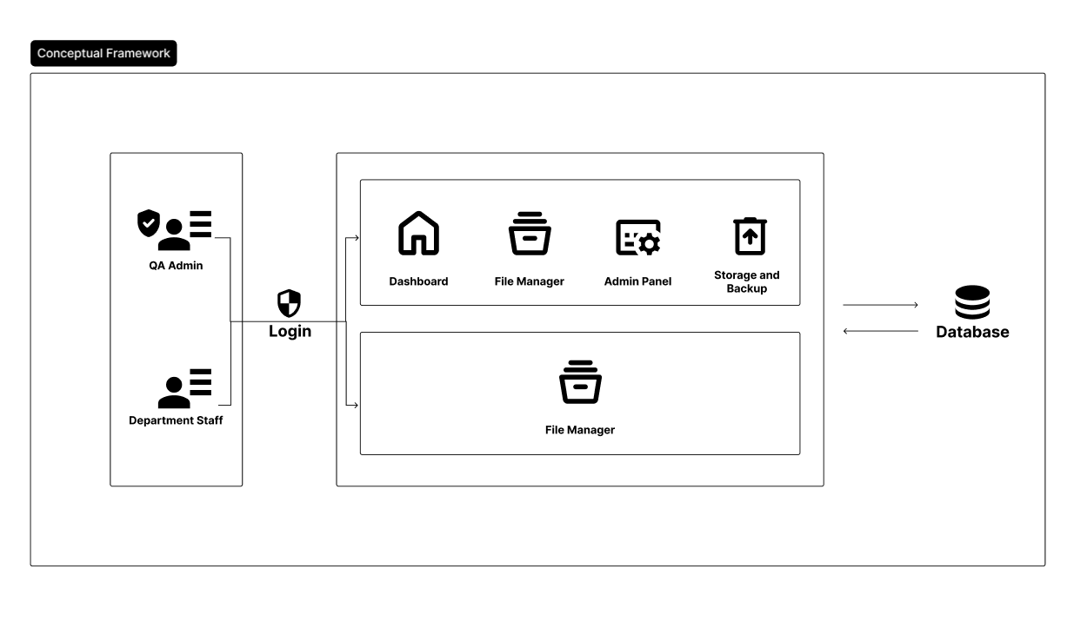
Conceptual Framework of the Study
Figure 2. Conceptual Framework of the Study
As depicted in Figure 1, the framework distinguishes two main user groups: the QA Admin and Department Staff, each accessing the system through a secure login interface. QA Admin users are granted comprehensive access to key modules, including the dashboard, admin panel, file manager, and storage and backup features. This full-spectrum access positions them to not only oversee and manage documents but also ensure overall system integrity, records authenticity, and institutional compliance.
Figure SEQ Figure \* ARABIC 2. Conceptual Framework for FilDAS
Department Staff users interact primarily with the file manager module, focusing on document upload, retrieval, organization, and classification. This targeted access streamlines departmental workflows while upholding security through clear role-based permissions. Both user types interact with a centralized database, which functions as the repository for documents and records all system activities. This architecture supports real-time document tracking, robust version control, audit trails, metadata management, and secure data backups.
By connecting users and modules to the shared database, the framework operationalizes the integration of Task-Technology Fit and Records Management Theory. This ensures that the system’s features are tailored to actual user needs while maintaining proper recordkeeping practices, enabling the QA office to transition from a fragmented, manual document process to a secure, efficient, and auditable digital environment. The resulting DMS not only automates and streamlines document workflows but also enhances accountability, user productivity, and the overall quality assurance function of the office.

Operational Definition of Terms
Quality Assurance (QA)
The process to ensure documents are accurate, organized, and meet quality standards in the QA office.
Document Management System (DMS)
Software that stores, organizes, tracks, and manages electronic documents to improve efficiency and security.
Automation
System-driven processes that reduce manual work in document handling.
Role-Based Access Control (RBAC)
A system that limits access to documents based on user roles to protect sensitive information.
Audit Trail
A record of all document actions to ensure transparency and accountability.
Metadata Tagging
Adding descriptive tags to documents for easier search and organization.
Notification Module
A system feature that alerts users of new or updated documents automatically.
Document Retrieval
The process of quickly finding and accessing stored documents.
Manual System
The existing paper-based or generic cloud storage methods used prior to this study.
Workflow Bottlenecks
Delays and inefficiencies caused by manual document management tasks.

Scope and Limitations of the Study
This study focuses mainly on the Quality Assurance (QA) office staff of Filamer Christian University and their use of document management practices. Some staff from other university departments may also be involved if needed to provide supplementary perspectives on document handling through the system. The research covers all types of documents managed by the QA office, including Word files, PDFs, and other digital formats typically used in university administration. The study compares the current manual system based on Google Drive with the proposed web-based Document Management System (DMS), examining system quality, information quality, service quality, user acceptance, user satisfaction, usage patterns, and security measures in the QA office context.
The study is limited to the QA office and a select group of staff users within Filamer Christian University, thus findings may not be generalized to other universities or organizations. Only QA office staff’s experiences are primarily explored, restricting broader institutional perspectives. Research data collection depends on available users’ feedback and system data, which may limit the sample size given the office’s staffing levels. The study timeframe and scope do not encompass long-term impacts or multiple academic periods, restricting assessment of extended system adoption effects. Lastly, user responses related to perceptions of system quality and acceptance may be subject to response bias, impacting the objectivity of those findings.
Significance of the Study
This study is significant in improving document management in the Quality Assurance (QA) office of Filamer Christian University by introducing a web-based Document Management System (DMS). The new system aims to address inefficiencies such as manual file handling, difficulty in tracking documents, and time-consuming organization processes. By automating these tasks and enhancing document accessibility, the study expects to improve productivity and efficiency in the QA office.
QA Office
The web-based DMS will help the QA staff reduce repetitive manual work, organize files more efficiently, and easily track documents. This will improve their workflow, save time, and allow them to focus on quality assurance tasks.
Other University Departments
The departments uploading files will benefit from easier document submission and improved coordination with the QA office, reducing confusion about file locations and versions.
University Administration
The system enhances data security and compliance by implementing strong confidentiality, integrity, and availability measures. This supports institutional policies and protects sensitive information.
Academic Contribution
This study also contributes to research by applying technology acceptance and information system success models within the context of educational document management. Its findings may guide future digital transformation efforts in universities.
Overall, the study supports the university’s move towards more efficient, secure, and user-friendly document management, ultimately benefiting staff, administration, and the institution’s quality assurance processes.

CHAPTER II
REVIEW OF LITERATURE AND STUDIES
Overview
Summary of Related Literature
Document Management Systems (DMS) have become essential tools across diverse sectors, including education, government, and business, to effectively manage the growing volume of documents. The evolution from manual, paper-based filing to digital, web-based platforms has resulted in significant improvements in document retrieval speed, secure storage, workflow automation, and operational efficiency. Recent studies demonstrate that web-based DMS implementations yield high user satisfaction, enhanced productivity, improved accuracy, and reduced operational costs.
Key features highlighted across the literature include role-based access control, integration of metadata standards, compliance with international standards (e.g., ISO), and the incorporation of emerging technologies such as barcode scanning, email/SMS notifications, and mobile accessibility. Security and confidentiality remain central concerns, with systems incorporating frameworks to protect sensitive data and ensure controlled access.
In educational institutions, DMS support critical functions such as academic record management, faculty evaluations, quality assurance, and accreditation processes, facilitating transparency and continuous improvement. Likewise, government and social welfare agencies benefit from streamlined document tracking and improved inter-departmental communication.
While technology plays a pivotal role, successful adoption also depends on factors beyond the system itself, including organizational culture, user training, stakeholder engagement, and collaborative development approaches. Challenges reported involve managing change, system scalability, technical complexities, and aligning system functionalities with diverse user requirements.
Despite these advances, there are still gaps in scaling DMS implementations beyond institutional levels, conducting long-term impact assessments, and exploring integration with mobile platforms and advanced analytics. Addressing these gaps is critical for future research to develop more comprehensive and adaptive document management solutions.
Design and Implementation of a Web-based Document Management System (Alade, 2023)
This study developed a web-based electronic document management system using OOHDM and standard web technologies to digitize organizational documents. It reported high user satisfaction (96.60%), accuracy (95%), and usability (99.20%), demonstrating improved productivity and data efficiency over paper-based methods.
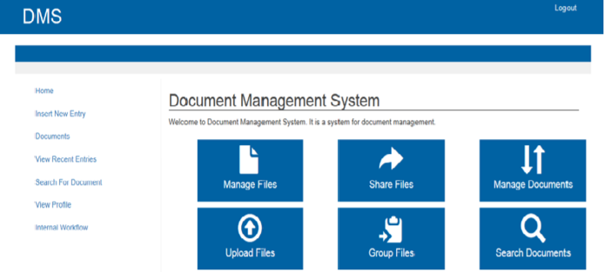
The home page as shown in Fig. #3 is the first page that a user sees after logging
Figure 3. home page
in to the system. It serves as the main page that directs users to other pages in the system. According to the dashboard displayed on the page, there are four sections on the form: insert new entry, create a new document, view recent document and search for document
Document Management System for Guangdong Vocational College (Zeng, 2024)
Focusing on an educational institution, this study developed a network-based DMS that integrated personnel management and file handling. It complied with ISO software standards and optimized system performance using caching and indexing. The DMS improved document accuracy and office efficiency, addressing security and collaboration challenges.
As depicted in Figure #4, the main functional modules of the document management system are displayed in the left navigation bar. Users can utilize this
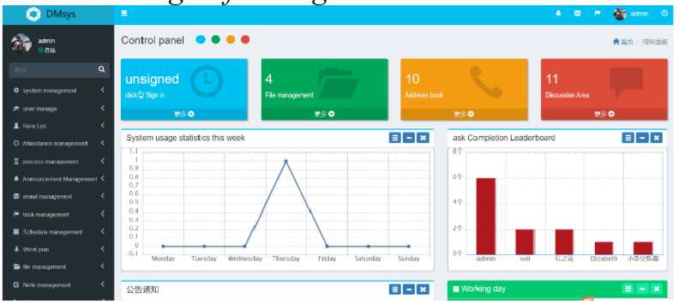
menu
Figure 4. DMS Modules
to access relevant operational information through the corresponding modules. Different personnel are granted varying levels of operational upon login, with administrators possessing the highest authority to configure permissions for each account.
Electronic Archive Management System: A Case Study in University of Basrah, Iraq (Badran & Hamoud, 2024)
This study presents a web-based Electronic Archive Management System developed for the University of Basrah to replace inefficient, paper-based employee file management. The system allows university employees and administrators to upload, store, and retrieve academic and administrative documents easily. It improves accuracy, reduces resource use, and speeds up data retrieval while supporting annual evaluations and statistical reporting. Challenges during development were managed with collaborative tools. Future plans include features for lecture uploads, student-professor communication, mobile apps, and tools to track teaching progress. The system enhances university employee record management and administrative efficiency.

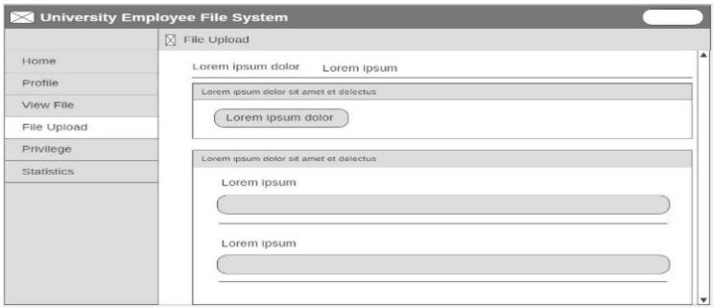
The file upload page is used to upload files of various types such as images, Word documents, Excel spreadsheets, PDFs, and others. This page includes a list to select employees mentioned in the file, such as acknowledgment letters, and other fields for uploading the file itself, specifying its type, providing details, and entering the date. as shown in figure #5
Figure 5. File Upload Page
Web-based Document Management System for Pagadian City Office (Nagrama et al., 2024)
The research developed a web-based system to replace manual document processes across elementary schools and an executive office. Employing the Waterfall model and multiple web technologies, it achieved high ratings in usability, reliability, and security, facilitating streamlined document submission and access.

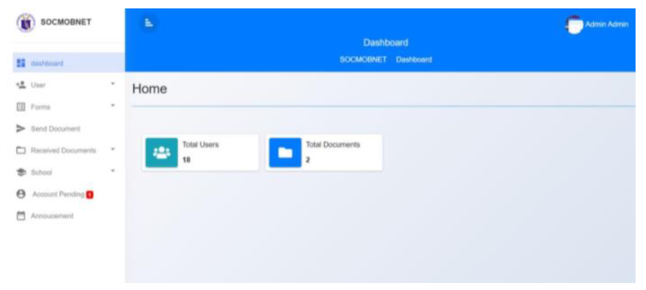
Figure #6 shows the interface of the main dashboard on the Administrator’s level
Figure 6. Main Dashboard Interface
where the concerned pertinent documents may be distributed to the schools within the locality through the School Principals who will download the documents and upload it back
Electronic Document Management System for LAN-Based Organizations (Gamido et al., 2023)
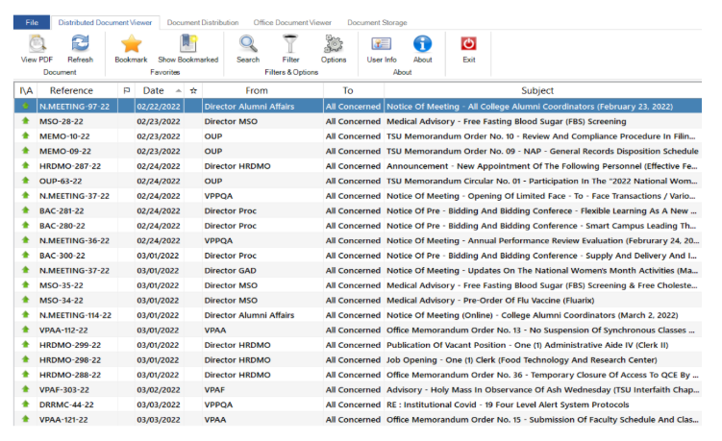
This study created an EDMS operating within a local area network, improving document indexing, storage, and retrieval. Using RAD methodology, it demonstrated high user satisfaction and operational efficiency, securing confidential documents and facilitating compliance with organizational policies.
Figure 7. Dashboard Document Viewer
The distributed document viewer module in the EDMS, as shown in Figure 8, provides a list of all uploaded documents for viewing by recipients. Access to the documents depends on both the user's confidentiality clearance and the distribution of the records office. Only users with a higher confidentiality clearance can view documents marked with high confidentiality levels. Only users assigned to the specific office that was tagged in the distribution of the records office can view the document in the list. To view a document, the user can double-click or right-click the selected document. The distributed document viewer also offers features such as bookmarking favorite documents, sorting documents in ascending or descending order, searching, and filtering documents.

Development and Implementation of Document Management System for Ilocos Sur Polytechnic State College, Tagudin Campus (Angala et al., 2022)
This study developed and implemented a web-based Document Management System (DMS) for Ilocos Sur Polytechnic State College (ISPSC) Tagudin Campus to address challenges in managing the increasing volume of paper documents. Despite growing digital trends, many institutions still rely on physical documents, leading to storage issues, difficult retrieval, and high operational costs. The DMS provides a centralized platform to capture, store, organize, and retrieve documents efficiently.
Using a standardized satisfaction survey (WAMMI) with 40 users, results showed strong user satisfaction regarding the system’s ability to arrange, track, and manage files. The study highlights the importance of adopting digital document management in educational institutions to improve workflow, protect information, and support organizational growth, especially as ISPSC transitions into a university with more campuses and users.
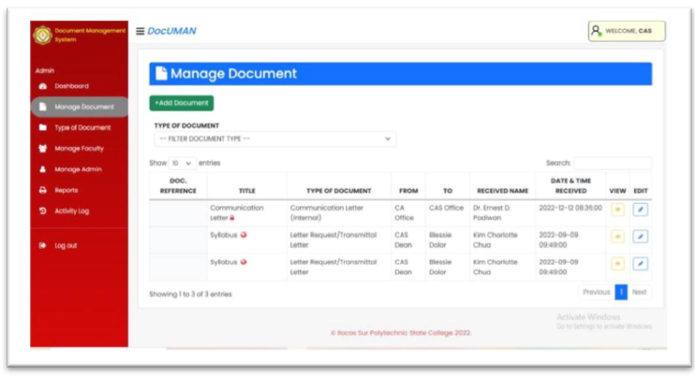
Figure 8. DocUMAN Manage Document Page

Figure #8 shows the add document button to upload new documents. The file’s metadata follows the Document Information Registry form maintained by the institution in accordance to ISO 9001.
Record Management System with Document Control (Pagayonan, 2021)
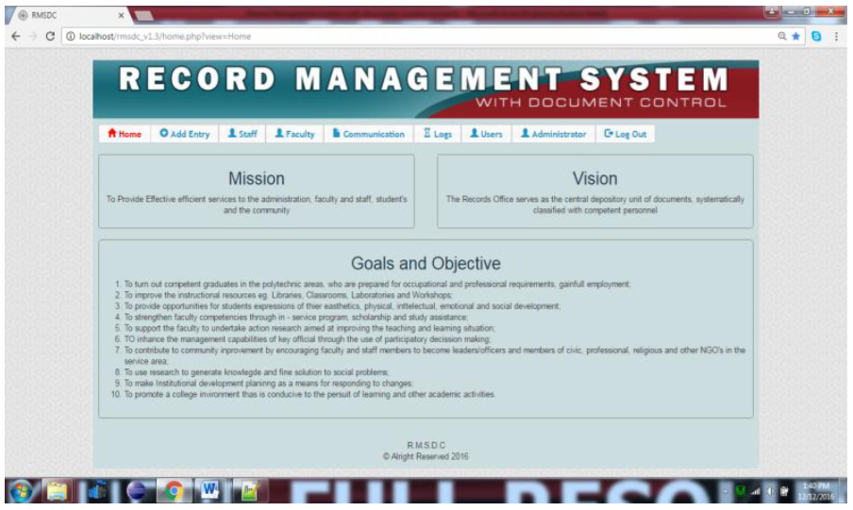
This study developed a web-based Record Management System with Document Control for Northern Iloilo Polytechnic State College (NIPSC) to digitize the handling of incoming/outgoing communications, employee leave applications, and human
Figure 9. Record Management System with Document Control main page
resource records. The manual paper-based processes caused delays and inefficiencies, particularly in retrieving records and calculating leave credits. Using surveys from 165 respondents and the ISO/IEC 9126 quality model, the system’s usability, functionality, and performance were all rated “Very Good.” The system simplified document receipt and release, streamlined leave monitoring, and improved access to employee records, resulting in reliable, time-efficient services that met user expectations. Figure #9 shows the Record Management System with Document Control main page.
Web-Based Electronic Document Tracking Management System (Jaquilmo & Sarmiento, 2023)
This study developed a web-based Electronic Document Tracking Management System for the Department of Social Welfare and Development (DSWD) Field Office V to address the inefficiencies of their manual, log-book-based document tracking. The existing system caused delays, misplaced files, and missed deadlines due to difficulty in locating and managing documents. The proposed system improves document handling by enabling classification, secure storage, retrieval, tracking, and preservation, enhancing communication and workflow efficiency.
The system features barcode scanning, email and SMS notifications, and role-based user access for streamlined document creation, approval, forwarding, and archiving. Its evaluation by IT experts and users showed high ratings in functionality, reliability, usability, efficiency, maintainability, and portability. Users found the interface user-friendly and the system effective in reducing manual processes and improving document monitoring. The study concludes that this electronic document tracking system offers a more efficient, reliable, and accessible solution for managing document flow in the DSWD Field Office V.
Synthesis and Commentary of Related Literature
The reviewed studies collectively affirm the critical need for transitioning from traditional paper-based document handling to digital document management systems (DMS) across various organizational settings, including educational institutions, government agencies, and local offices.
Most studies, such as those by Alade (2023), Zeng (2024), and Angala et al. (2022), focused on creating web-based DMS platforms that streamline document capture, storage, retrieval, and management. These systems significantly improve productivity, accuracy, and ease of access compared to manual filing, as demonstrated by high user satisfaction and usability ratings consistently reported (e.g., above 90% in Alade, 96.6% satisfaction). These platforms often conform to international standards (ISO compliance in Zeng, metadata standards in Angala et al.) which enhance their reliability and facilitate institutional integration.
Several projects uniquely emphasized specialized functionalities to fit their organizational contexts. For example, Badran and Hamoud’s (2024) system tailored to university archives supports academic evaluations and statistical reporting, while Pagayonan’s (2021) system integrates leave management with record control, addressing specific administrative workflows. Meanwhile, Jaquilmo and Sarmiento (2023) enhanced document tracking through barcode scanning, SMS, and email notifications to support government office operations, indicative of a trend towards incorporating emerging technologies for comprehensive workflow management.
The reviewed systems also demonstrate improved control over document security and confidentiality, a critical feature underscored in Gamido et al. (2023), which employs user-level confidentiality clearances within a local network environment. Similarly, Zeng (2024) addressed collaboration and security issues particularly relevant for large educational institutions.
Common challenges discussed include managing user access rights, system scalability, and ensuring seamless usability, which many studies tackled through modular design and role-based permissions (e.g., Zeng, Jaquilmo & Sarmiento). Additionally, collaborative development approaches, such as the use of Git in Badran and Hamoud (2024), highlight best practices for managing complexities during system implementation.
A recurring limitation across these studies is the primarily institutional or campus-limited deployment, with most systems not yet scaled to regional or national levels. Furthermore, while user satisfaction and technical functionality are generally well-assessed, long-term impact studies on organizational efficiency and cost savings remain sparse.
In conclusion, the literature underscores an evolving ecosystem of web-based and networked document management solutions tailored to diverse settings but grounded on core functionalities of digitization, accessibility, and control. Future research may explore more integrated, cross-institutional systems, mobile platform expansion, and advanced analytics for document usage and workflow optimization as suggested by prospective features in Badran and Hamoud (2024) and others.

CHAPTER III
METHODOLOGY
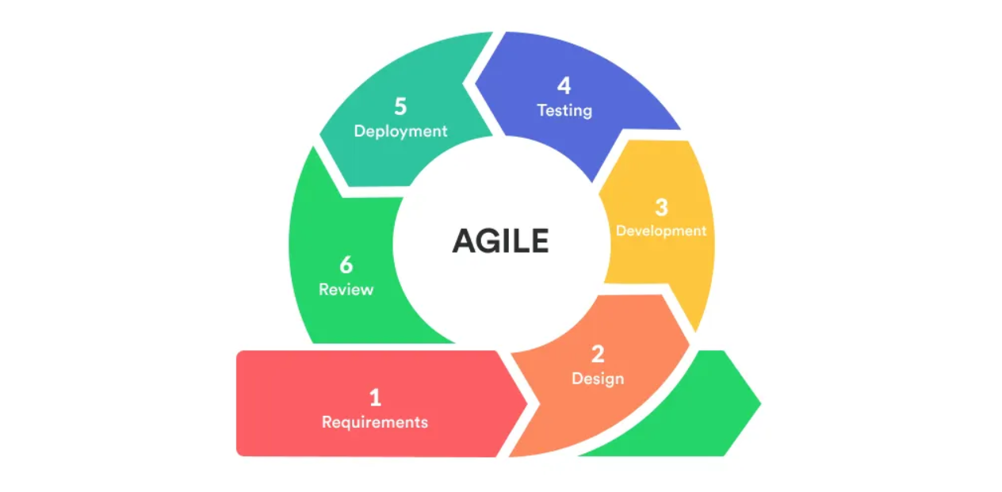
This chapter presents the research methods, procedures, and tools used in the design, development, and evaluation of the proposed FilDAS Document Management System (DMS) for the Quality Assurance (QA) Office at Filamer Christian University. It outlines the research design, data collection strategies, system development framework, and evaluation metrics guiding the study.
Figure 10. METHODOLOGY
Research Design
The study employs a combination of developmental and descriptive research designs. The descriptive aspect involves identifying and analyzing the current manual document management challenges faced by the QA Office, while the developmental design facilitates the systematic creation, implementation, and evaluation of the automated DMS. The integration of these designs ensures a comprehensive understanding of the problem and supports the creation of an effective, user-centered solution.
To operationalize system development, the Agile methodology was adopted. Agile’s iterative process divides the project into manageable cycles called sprints, each delivering functional system modules. This allows continuous incorporation of user feedback from QA staff and selected department representatives, ensuring the DMS evolves according to real user needs and preferences. Agile’s flexibility also accommodates changes in requirements that may arise during development, minimizing the risk of misalignment between system features and organizational goals.
Data Collection Methods
To achieve the study’s objectives, multiple data collection methods were employed. Semi-structured interviews were conducted with QA staff and personnel from the College of Computer Studies to gather detailed insights about current document handling workflows, challenges, and desired system features. These interviews helped identify critical bottlenecks and user expectations for automation, security, and ease of access.
Additionally, direct observation was carried out to examine existing document processing activities and to evaluate how the proposed system influenced workflow efficiency post-deployment. System usage logs were collected throughout the testing and implementation phases to provide objective data on user interactions, frequency of access, and document retrieval times.
While questionnaires could supplement this data, the small number of users made in-depth qualitative approaches more appropriate for capturing nuanced user experiences and perceptions.
Requirement Gathering
Requirement gathering was a critical phase conducted through stakeholder meetings and interviews with the QA Office and department representatives. These sessions aimed to elicit specific system functionalities such as automated document uploading, real-time notifications, role-based access control, audit trails, and metadata tagging capabilities.
User stories were developed to capture key workflows and scenarios, ensuring system features directly addressed the real-world tasks users perform. Comparative reviews of similar document management systems in academic environments were also conducted to identify best practices and potential features beneficial for Filamer Christian University.
Prioritization of requirements was achieved through collaborative discussions, focusing on the most impactful and feasible functionalities to guide the development roadmap.
System Development Methodology
The Agile development framework guided the system’s creation. The project commenced with planning and requirements analysis, followed by iterative design and prototyping using React with TypeScript for the frontend, styled by Tailwind CSS. Laravel served as the backend framework, with MySQL as the database system to ensure robust data management and security.
Each sprint focused on developing specific modules, such as the file manager, dashboard, and notification system, which were followed by testing phases including unit and integration tests, as well as user acceptance testing involving the QA staff and department representatives.
Feedback obtained at the end of each sprint was incorporated to refine system features, enhance usability, and fix issues prior to subsequent development cycles. Upon completion, the system was deployed within the QA Office environment alongside training sessions to facilitate smooth user adoption.
Tools and Technologies
The development utilized the following tools and technologies:
- Frontend: React with TypeScript, leveraging Tailwind CSS for responsive and consistent UI design.
- Backend: Laravel PHP framework, chosen for its robustness and security features.
- Database: MySQL, providing reliable and scalable data storage.
- Data Collection Instruments: Interview guides, observation protocols, and automated system usage logging.
- Data Analysis Software: Manual qualitative coding supported by Microsoft Word and Excel for thematic analysis.
Evaluation Metrics
The effectiveness of the FilDAS Document Management System was evaluated based on several criteria. User satisfaction and system usability were
primarily assessed through qualitative interviews and observations, focusing on perceived improvements in workflow efficiency, document retrieval time, and error reduction.
System reliability and security were gauged through monitoring audit logs and access control effectiveness. Additionally, operational efficiency was measured by comparing time spent on document management tasks before and after system implementation.

Ethical Considerations
Throughout the study, strict ethical standards were maintained. All participants were briefed on the research objectives and provided informed consent prior to data collection. Confidentiality was ensured by anonymizing participant data in reports and securely storing all collected information with access limited to the research team.

BIBILIOGRAPHY
Alade, S. M. (2023, April 8). Design and implementation of a web-based document management system. International Journal of Intelligent Technologies and Computer Science, 15(2). https://www.mecs-press.org/ijitcs/ijitcs-v15-n2/IJITCS-V15-N2-4.pdf
Zeng, X. (2024, June). Document management system. The Light Explorer, 9(2). https://www.thelight-explorer.com/wp-content/uploads/2024/08/Art-480-Zeng-XiangDong_Edited_Luyunformated-by-angelo-Jan-2024.pdf
Badran, A. S., & Hamoud, A. K. (2025, August). Electronic archive management system: A case study in University of Basrah, Iraq. Southeast Europe Journal of Soft Computing, 13(2), 1-9. https://www.academia.edu/130315371/Electronic_Archive_Management_System_A_Case_Study_in_University_of_Basrah
Nagrama, N. D. C., Lingating, M. L. D., Calleno, J. T., Rato, R. K. A., Catungal, M. L. P., & Encarnacion, P. C. (2024, June 7). Web-based document management system. International Journal on Science and Applied Information Technology, 13(3). https://www.warse.org/IJSAIT/static/pdf/file/ijsait031332024.pdf
Gamido, M. V., Gamido, H. V., & Macaspac, D. J. P. (2023, August). Electronic document management system for local area network-based organizations. International Journal of Electrical and Computer Engineering Systems. https://ijeecs.iaescore.com/index.php/IJEECS/article/viewFile/30040/17516
Angala, D. T., Casugay, B. C. O., Estillore, H. M. Q., Lebantino, J. B., Marcha, S. O., Valdez, J. E. C., & Villanueva Jr., G. R. (2023). Development and implementation of document management system for Ilocos Sur Polytechnic State College, Tagudin Campus. E-DAWA: An International Multidisciplinary Research Journal, 3(Special Issue), June. https://drive.google.com/file/d/1fFryE6VSKAFT9OcGptkFU5qgmqjSkCVj/view
Pagayonan, S. M. S. (2021, December 12). Record management system with document control. International Journal of Multidisciplinary Research and Analysis, 4(12), 1929–1934. https://ijmra.in/v4i12/Doc/23.pdf
Jaquilmo, C. A., & Sarmiento, J. R. (2023, May 23). Web-based electronic document tracking management system. Global Scientific Journal, 11(5). https://www.globalscientificjournal.com/researchpaper/WEB_BASED_ELECTRONIC_DOCUMENT_TRACKING_MANAGEMENT_SYSTEM.pdf

